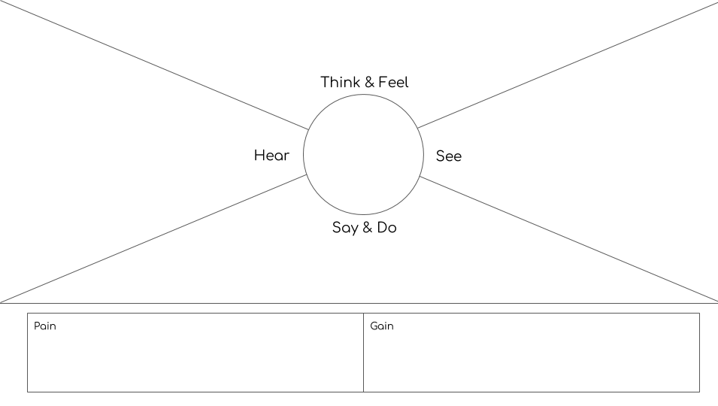

MAKING THIS IS POSSIBLE

BABY WILL GET HARMED OR NOT

Is it possible to make the smart stroller

How the wheels get locked automatically

Is it safe to keep handle bar smart